
IMAGINE HOLIDAYS
&
 TAJ PROMOTIONS
PRESENT
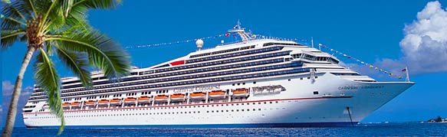
DO MAJA CRUISE

“THE ULTIMATE CRUISING EXPERIENCE”

Departure Date: November 12, 2006

7 Day Exotic Western Caribbean Itinerary

On the Newest and Largest Mega “Fun Ship”

Departure Date: November 12, 2006

Ports of Call:

Belize, Isla Roatan (Honduras), Grand Cayman & Costa Maya (Mexico)

Enjoy fabulous entertainment provided by the cruise line

Plus EXCLUSIVE for the Do Maja Cruisers
Dandia-Raas-Garba & Bollywood Music nights by our own


Karim Khimji’s Orchestra

Karim, Fatima, Amin, Shankar, Vikas & Parichay

AND
Gazal and Bhuli Bisri Yaaden nights
With Shiraz Walli

FUN FILLED DAYS AND FESTIVE NIGHTS WILL ALSO INCLUDE:

- Fine cuisine by Carnival including exclusive Indian meals for Do Maja Cruisers
- Do Maja Cards Tournaments
- Karaoke Sing-along, stand up comedy & social get-togethers in our own private lounges.

Lead in price: $899 CAD per person based on double occupancy (cruise only)

OPTIONAL: Miami excursion (3 days) immediately following the Do Maja cruise

For further information please contact

Nashila Remtulla, President, Imagine Holidays – Fully licensed Travel Agency (TICO)

Tel: 905-881-0800 or 416-315-4898 (cell)
email – nashila@imagineholidays.ca
2300 John Street, Thornhill, ON L3T 6G7

